Day: 17 (04-11-2026) | Data Loading, Transformation and Visualization using PowerBI | Documented By:
Task – 3 | Data Loading, Transformation and Visualization using PowerBI | Sujit T K

- Load .csv data into Power Query Editor
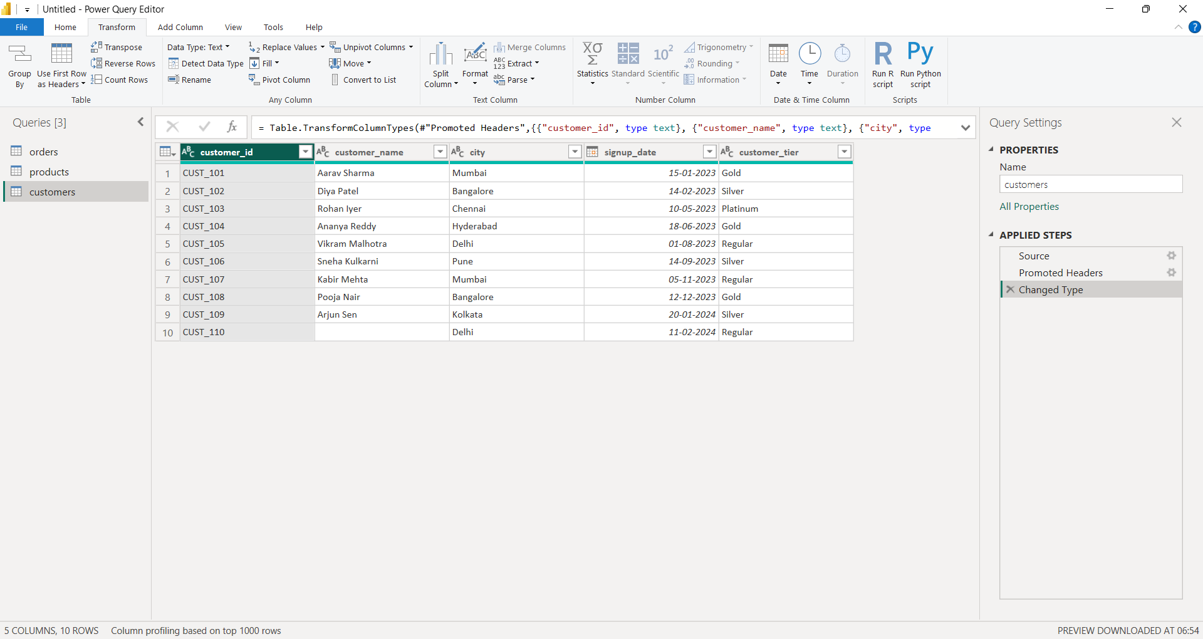
- Perform Transform operations such as UPPERCASE, TRIM
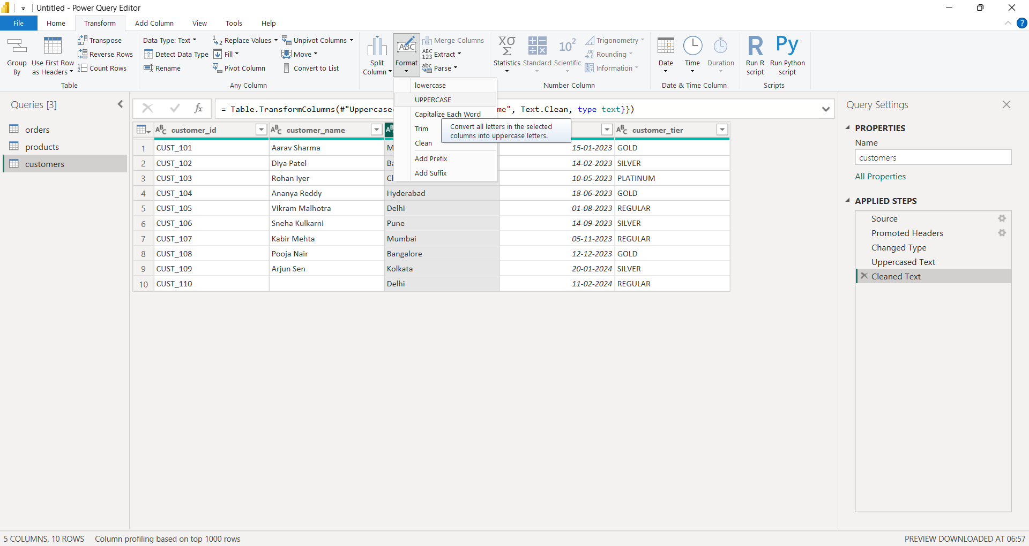

- Convert datatype of each column to its appropriate format (signup_date column should be of date datatype)
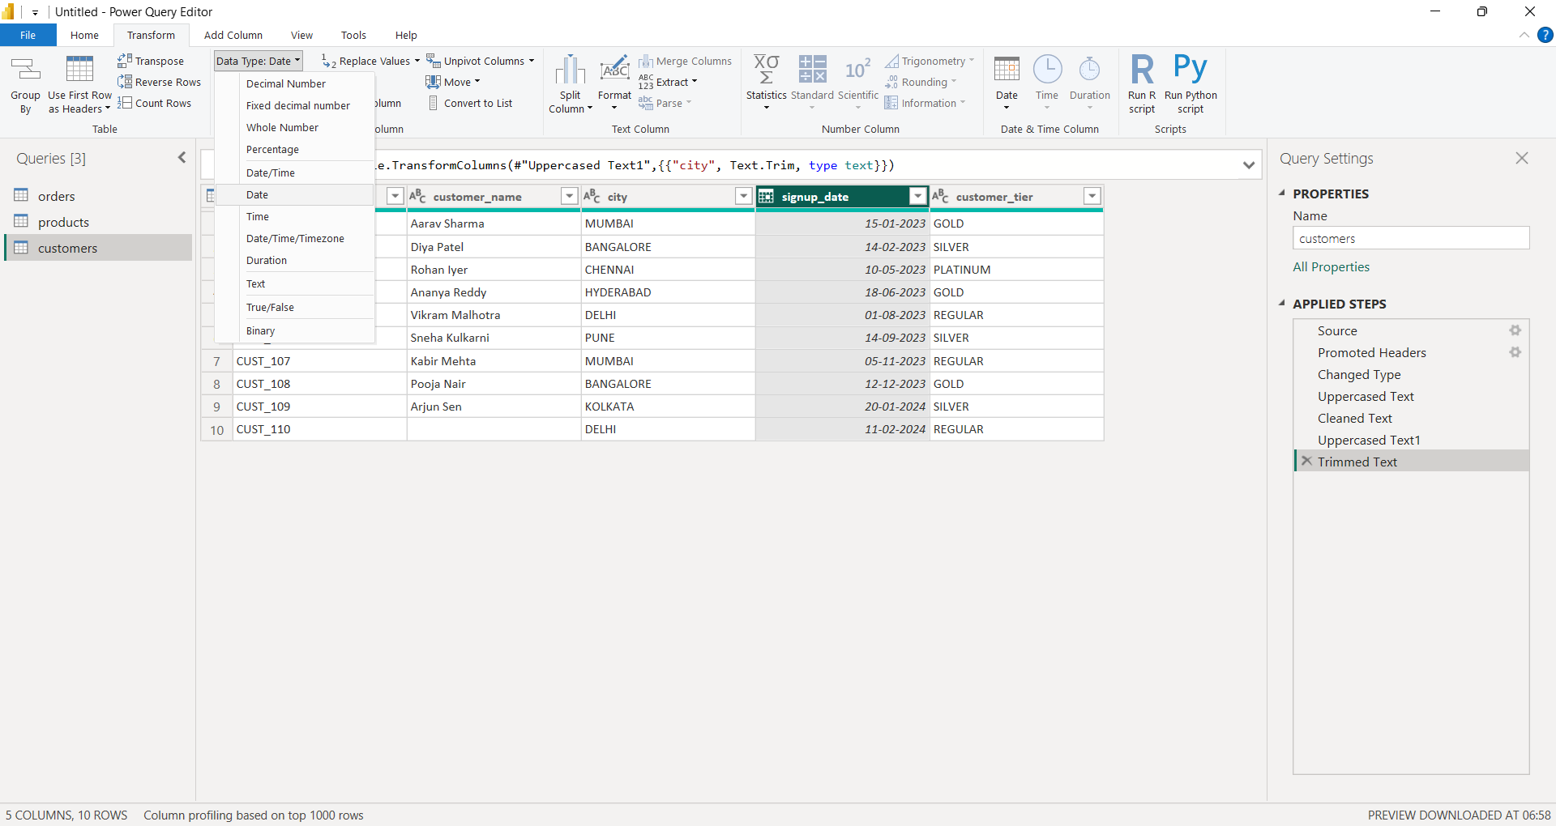
- Merge tables using common columns
4.1.1) Merging Orders and Customers table using customer_id common column
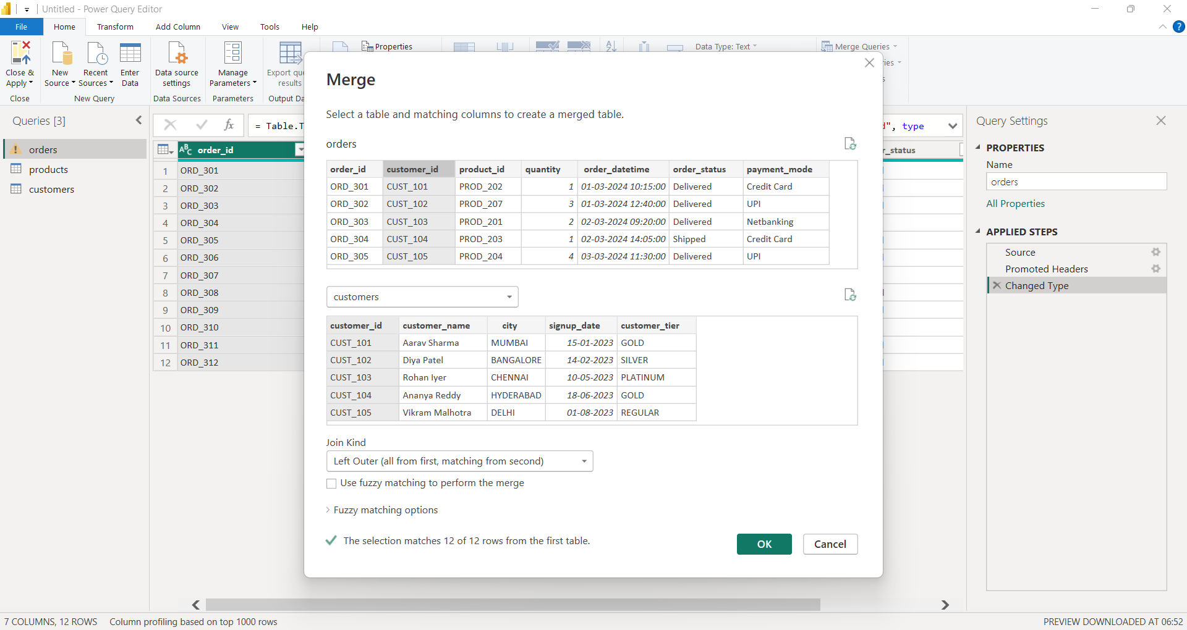

4.1.2) Select only the necessary columns
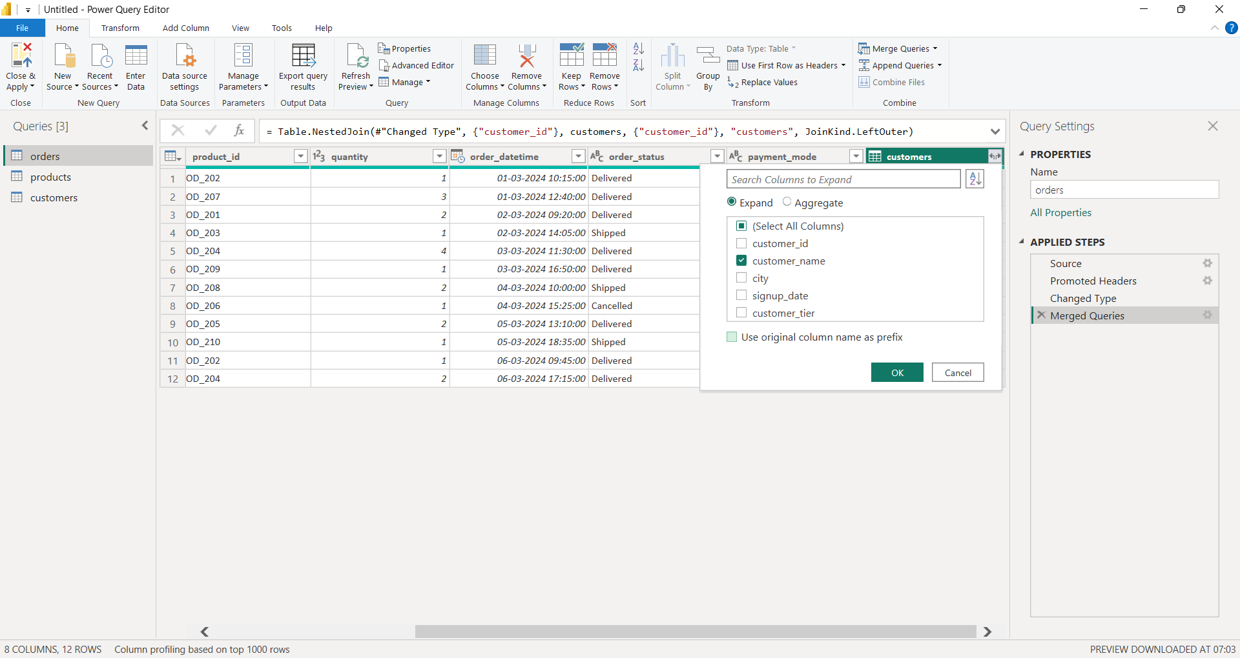
4.2.1) Merging Orders and Products table by common column product_id
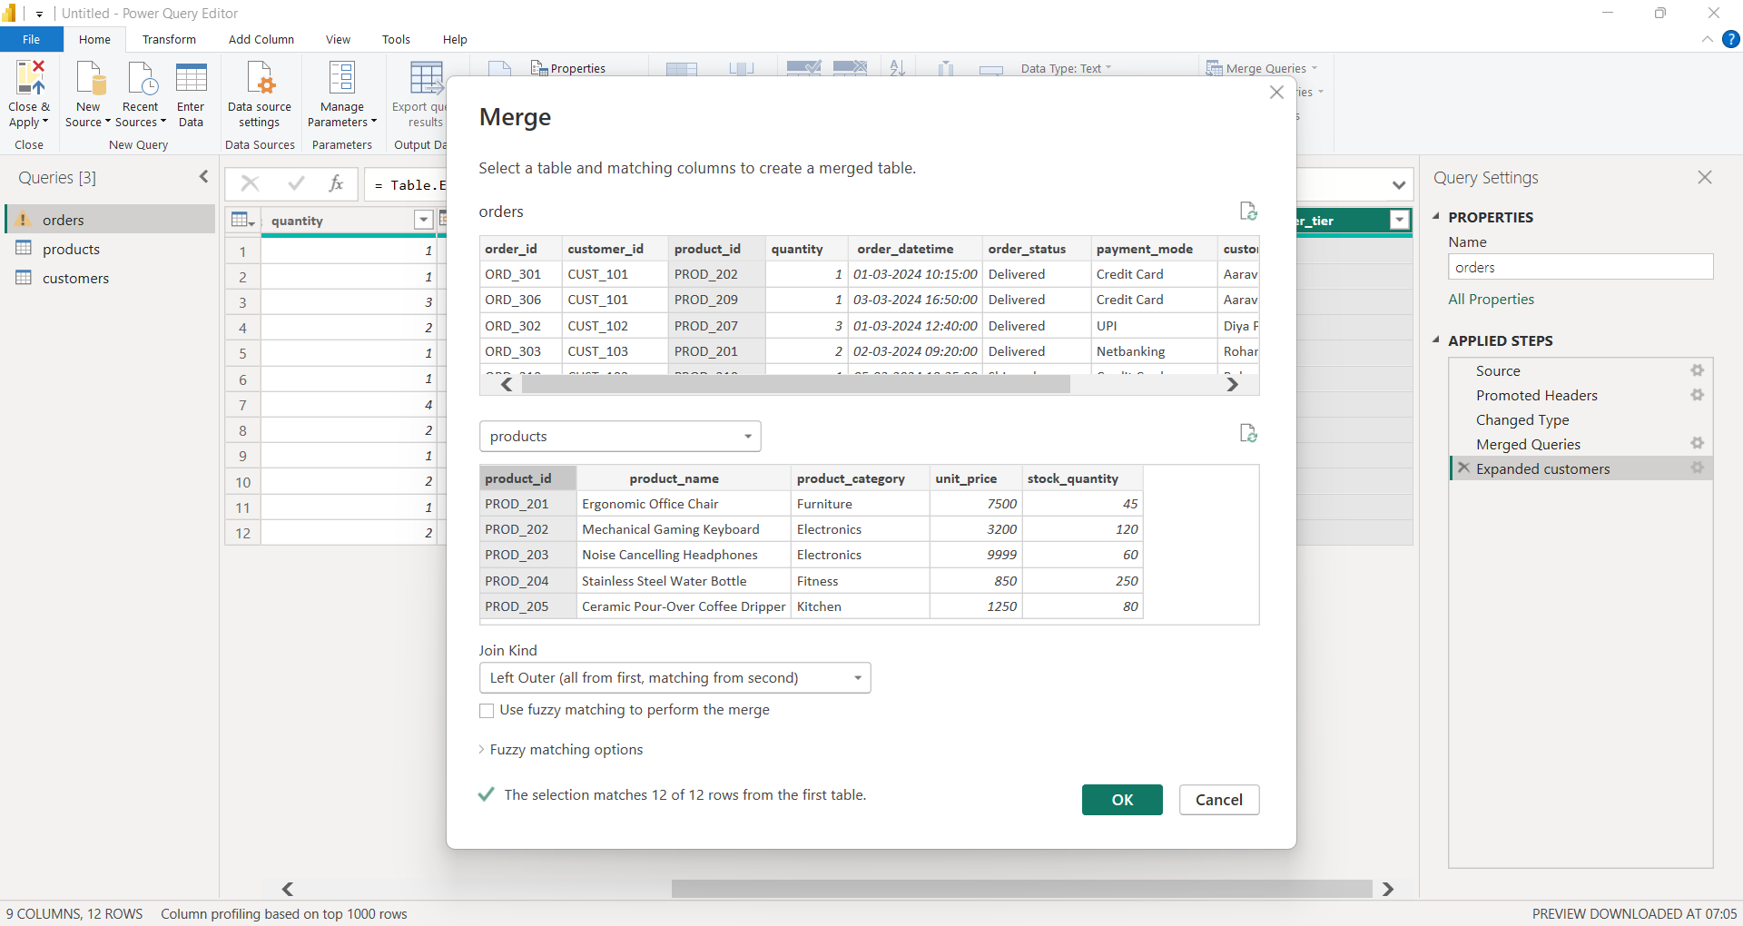

4.2.2) Select the necessary columns to be displayed
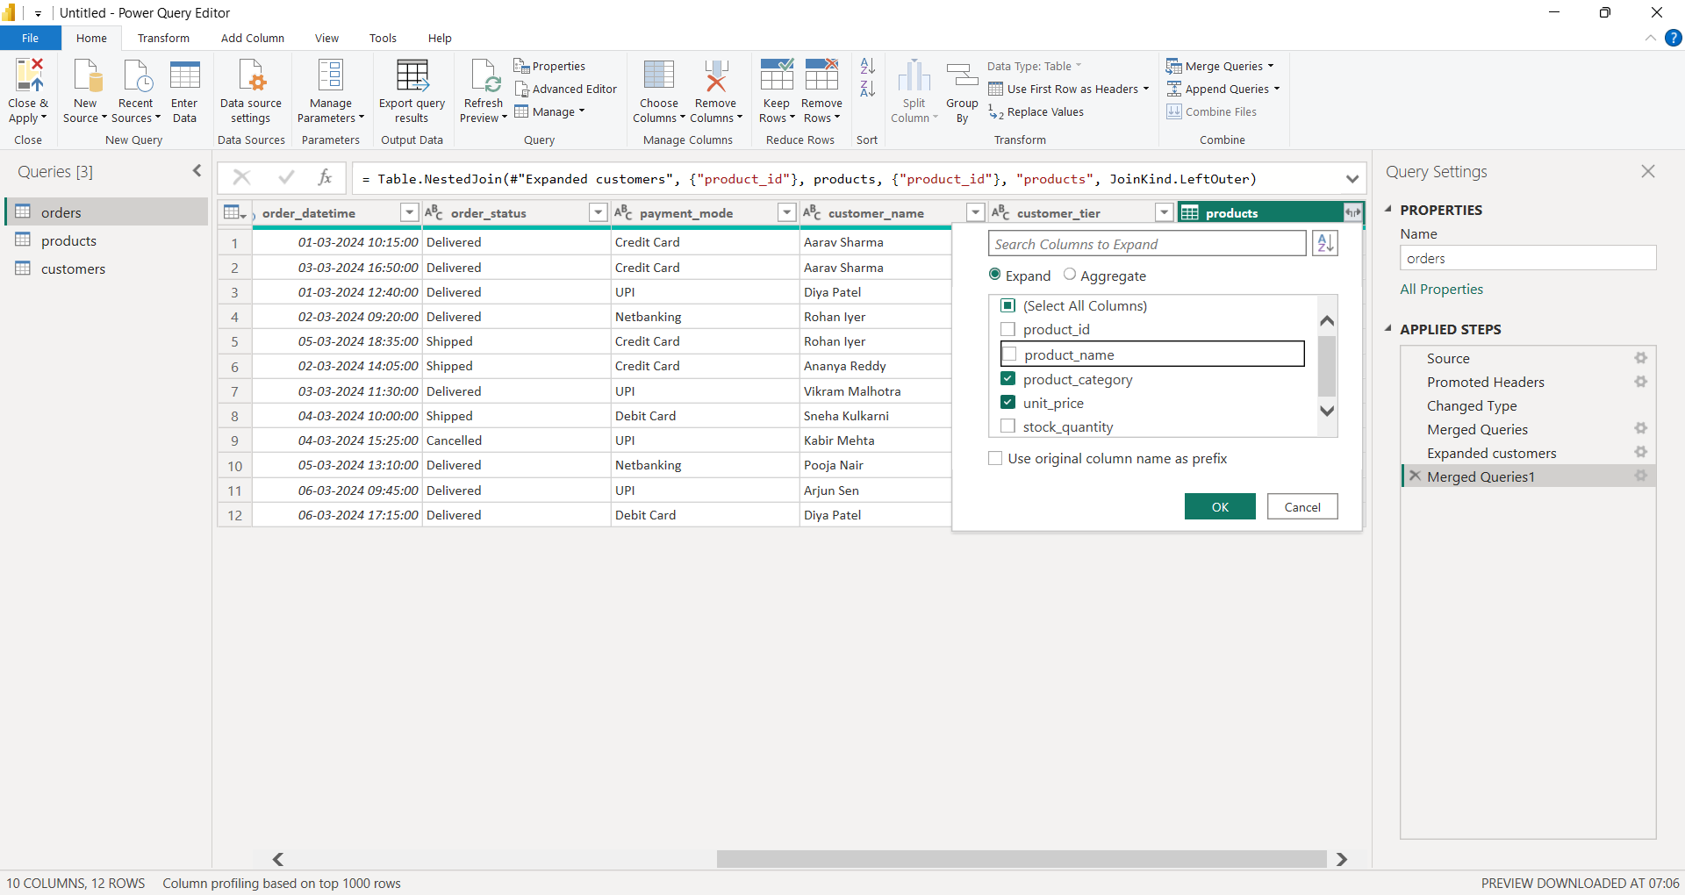

- View the table content to verify all required columns are present
customer_name and customer_tier are from Customers table
unit_price and product_category are from Products table
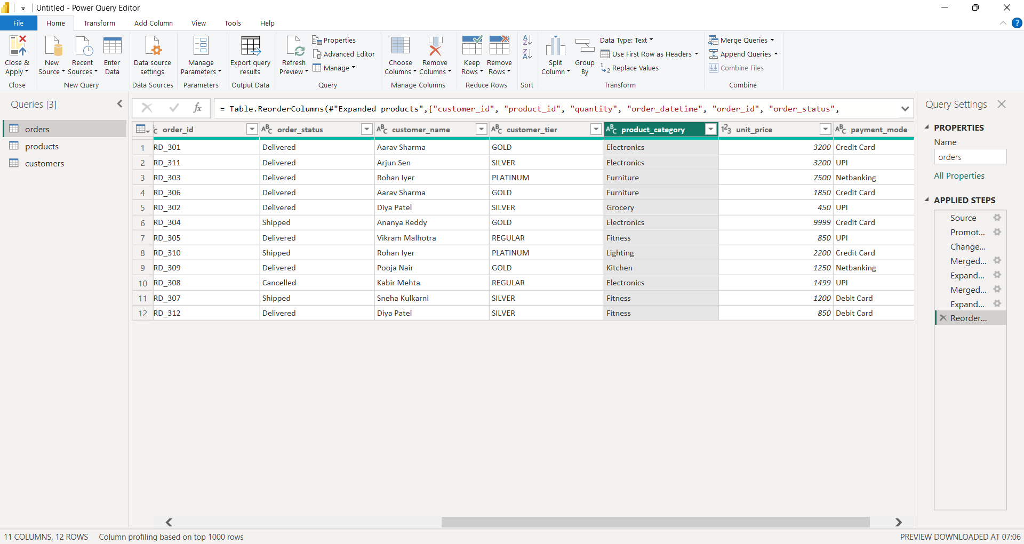

- Creating a custom column to calculate revenue
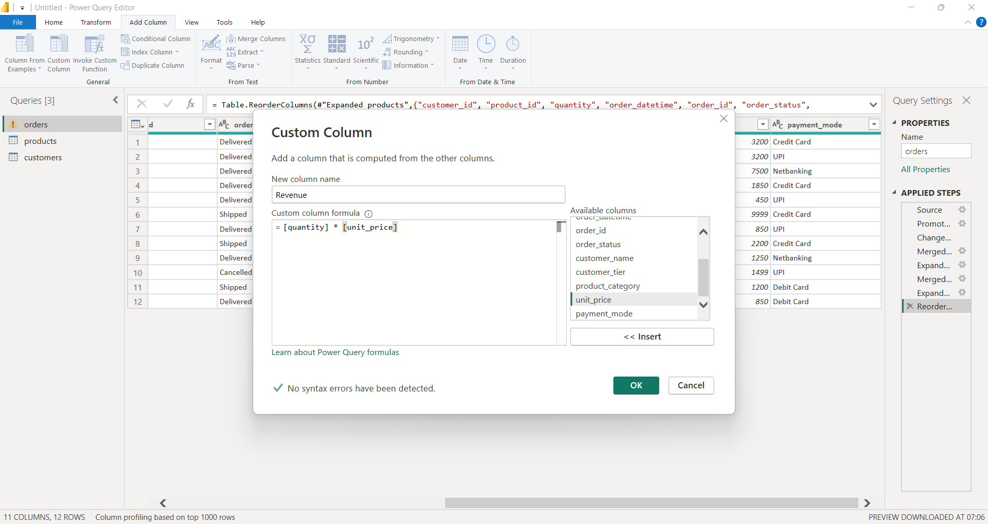

New column ‘Revenue’ populated with the value by the column formula
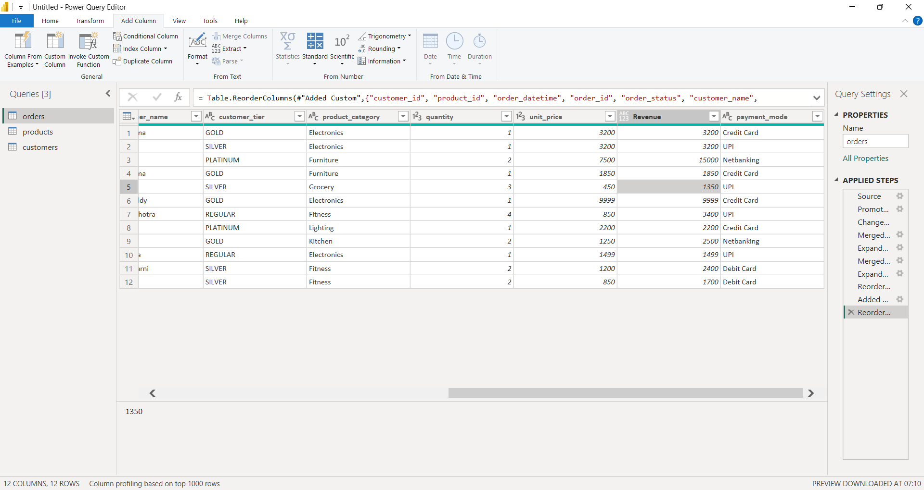

- ‘Close & Apply’ to exit Power Query Editor
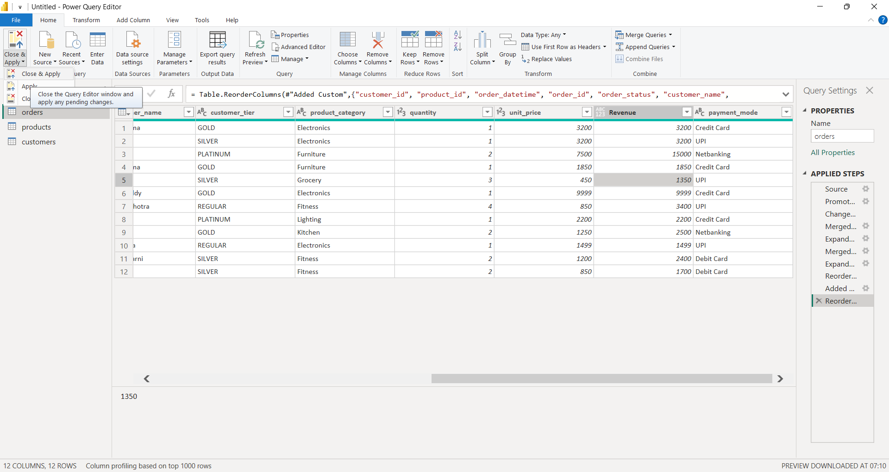

- Wait for data to be loaded into Power BI desktop
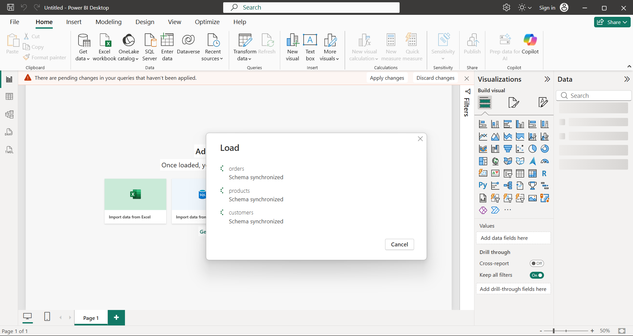

- Create relationship between tables
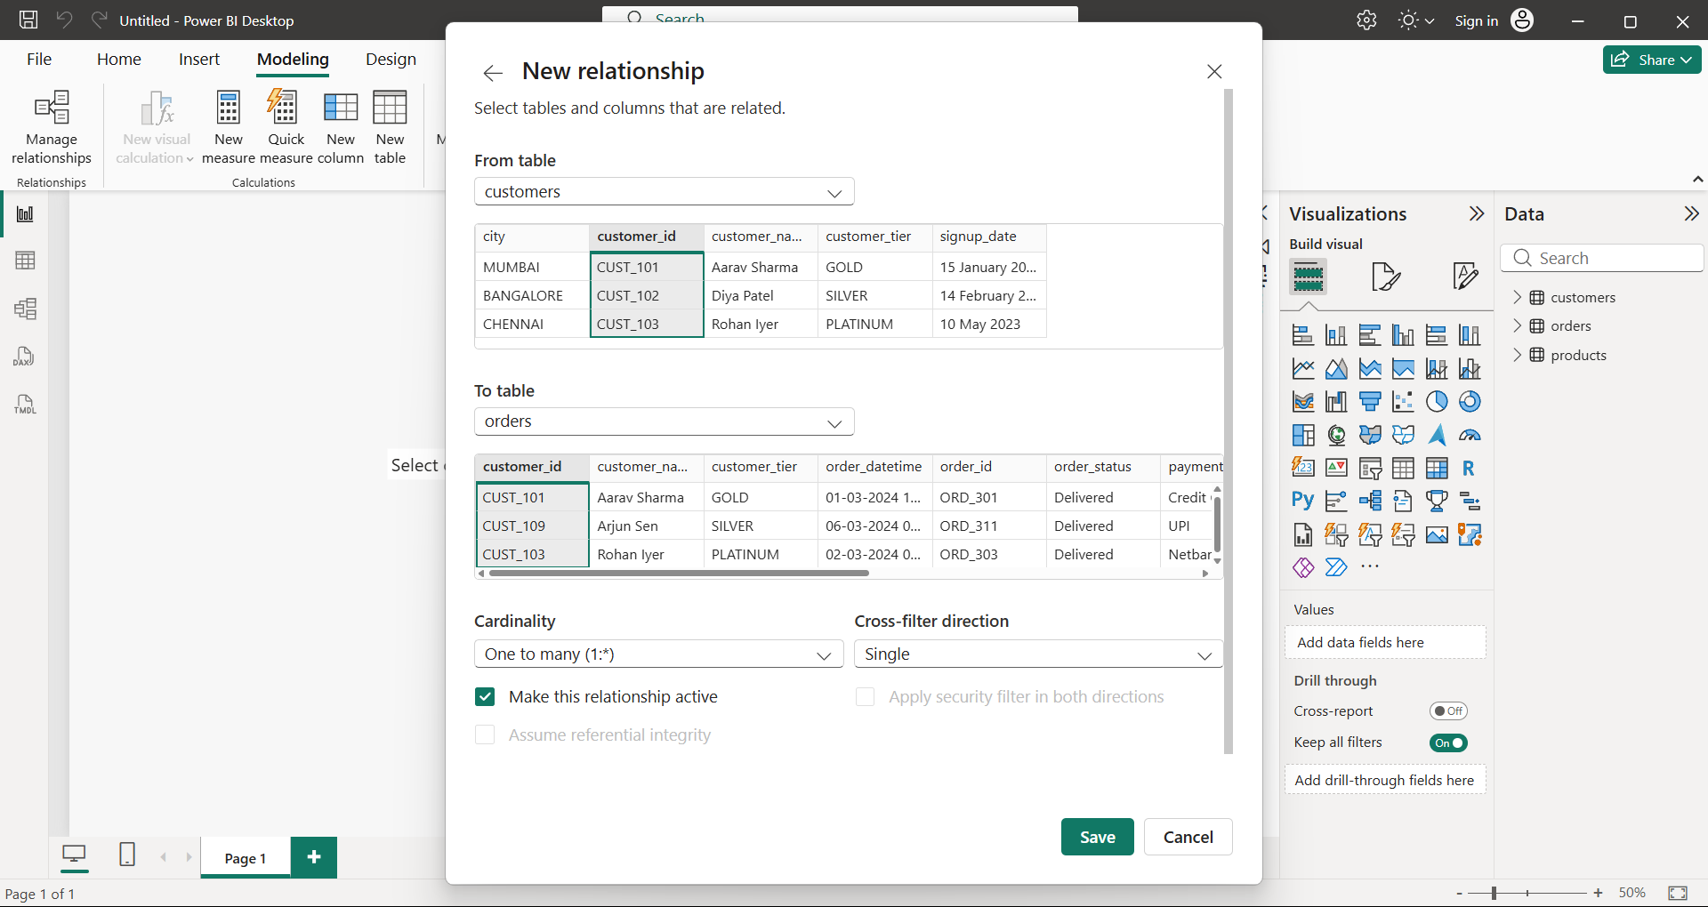

- Create Visualization using tables and charts


